**INFORMED CONSENT FOR SILVER DIAMINE FLUORIDE **

**Facts for consideration:**

* Silver Diamine Fluoride (SDF) is an antibiotic liquid. It is used on cavities to help arrest tooth decay. It is also used to treat tooth sensitivity. SDF application every 6 to 12 months is necessary.
* The procedure: 1) Dry the affected area, 2) Place a small amount of SDF on the affected area, 3) Allow SDF to dry for one minute, 4) Rinse.
* **Treatment with SDF does not eliminate the need for dental fillings or crowns to repair function or esthetics.**
* 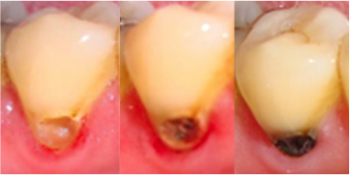A patient should not be treated with SDF if: 1) they are **allergic to silver,** 2) there are painful sores or raw areas on the gums (i.e., ulcerative gingivitis) or anywhere in the mouth (i.e., stomatitis).

**Benefits of receiving SDF:**

* SDF can help arrest tooth decay and relieve sensitivity.

**Risks related to SDF include, but are not limited to:**

* **The affected area will stain black permanently.** Healthy tooth structure will not stain. Stained tooth structure can be replaced with a filling or a crown at some point in the future.
* Tooth-colored fillings and crowns may discolor if SDF is applied to them. Color changes on the surface can normally be polished off. The edge between a tooth and filling may keep the color.
* If accidentally applied to the skin or gums, a brown or white stain may appear that causes no harm, cannot be washed off, and will disappear in one to three weeks.
* The patient may notice a metallic taste. This will go away.
* If tooth decay is not arrested, the decay will progress. In that case, the tooth will require further treatment, such repeat SDF, a filling or crown, root canal treatment or extraction.
* These side effects may not include all of the possible situations reported by the manufacturer. If you notice other effects, please contact the California Dental Association at 916-554-7373.
* Every reasonable effort will be made to ensure the success of SDF treatment. There is a risk that the procedure will not stop the decay and no guarantee of success is granted or implied.

**Alternatives to SDF, not limited to the following:**

* No treatment, which may lead to continued deterioration of tooth structures and cosmetic appearance. Symptoms may increase in severity.
* Depending on the location and extent of the tooth decay, other treatment may include placement of fluoride varnish, a filling or crown, extraction or referral for advanced treatment.

**I CERTIFY THAT I HAVE READ AND FULLY UNDERSTAND THIS DOCUMENT AND ALL MY QUESTIONS WERE ANSWERED:**

**____________________________**(signature of patient or legal guardian) ________________________________(signature of witness)

___________________(date) ___________________(date)